Central Baptist Church
Sunday April 14, 2024
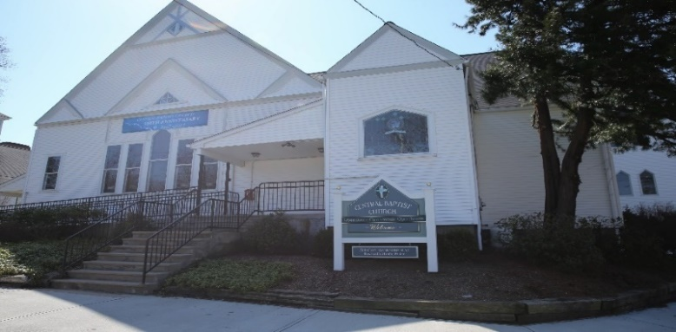

Welcome/Announcements
Welcome to Worship today.

It is my joy to walk alongside you all, in this time of discernment …

With you, in tending your flock, listening and wondering,
perhaps planting new seeds …

About where the Holy Spirit is calling us, seen or unseen …
walking beside us, and listening together, as a church in transition.
It is my joy to walk alongside you all, in this journey.

I welcome your thoughts about faith, coffee, and conversation,
and maybe refreshing walks around town. Good Dogs welcome ~

*Hymn What a Friend We Have in Jesus No. 435

Responsive Call to Worship
O God, in you, we live and move and have our being,
Guide and govern us in this day by your Holy Spirit,
that in all the cares and occupations of our life
we may not forget you, but remember that always
we are walking in your sight, through Jesus Christ,
our Lord and Saviour. Amen.

Unison Prayer of Invocation
Loving God, remind us, that your story is our story,
for we are your children, whom you deeply love.

Direct our hearts and lives now and always.
May our worship be pleasing to you, and a blessing
in the life of our journeys near and far. Amen

*Gloria Patri No. 623
Glory be the Father and to the Son and to the Holy Ghost, as it was in the beginning, is now and ever shall be, world without end. Amen, Amen.

Anthem

Children’s Message

Sharing of Joys & Concerns
Thank You, Gracious God, for never giving up on us,
for forgiving us countless times,
and for welcoming us, when we are prone to wander.

We pray that through our worship, and care in the community,
that others may know your grace O Lord,
along with your forgiveness, and encouraged,
in the journey of faith, and most of all,
to guide us in sharing your mercy,
and bearing the gifts of care, to others, always. Amen.

Pastoral Prayer & The Lord’s Prayer
Our Father, who art in heaven, hallowed be thy name. Thy kingdom come, Thy will be done, on earth as it is in heaven. Give us this day our daily bread. And forgive us our trespasses as we forgive those who trespass against us. And lead us not into temptation but deliver us from evil. For thine is the kingdom, and the power, and the glory, forever. Amen.

Offering & Offertory

Friendship Forms
Please pass the friendship pad in your pew to each person to sign. If you would like to be contacted by someone in the congregation, please leave a note with an e-mail or phone number.

*Doxology No. 625

Scripture

John 1:39

Sermon “Come & See “

*Hymn For the Beauty of the Earth No. 560

Benediction
As we prepare to go back out, into the world around us,
and new trials and mercies come our way,
may we share this blessing:
May the Lord bless you and keep you,
May the Lord shine his face upon you,
with the gifts of grace and peace,
in the name of Jesus Christ.
Pastor Sandra D’Amico

Postlude

*Please stand if you are able

