Central Baptist Church
Sunday April 28, 2024
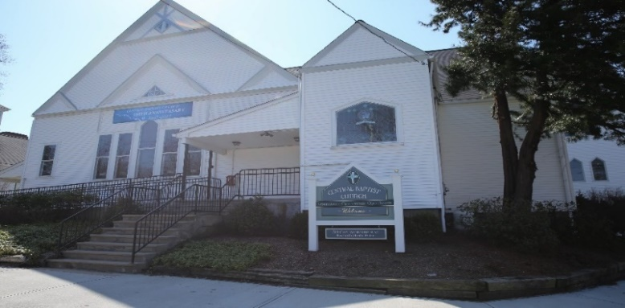

My command is this: Love each other as I have loved you. john15:12

Welcome/Announcements

*Hymn No.

Call to Worship
One: We delight ourselves in the presence of Christ and his love for all creation.
All: Let us open our hearts to receive Christ’s abundant love.
One: Christ calls us to see him as the vine and for us to become the branches.
All: Let us seek to produce much fruit in God’s Garden where all are welcome.
One: Come, let us worship the Master Gardener, Creator of all that was, is and forever
will be.
All: Amen

Unison Prayer of Invocation
Living God, we embrace your presence in our lives. Help us to grow stronger together in your garden of love. Plant us together in your peace. Root us together in your hope. Transform us together by your equal justice for all. In your loving presence, we pray. Amen.

*Gloria Patri No. 623
Glory be the Father and to the Son and to the Holy Ghost, as it was in the beginning, is now and ever shall be, world without end. Amen, Amen.

Anthem

Children’s Message

Sharing of Joys & Concerns

Pastoral Prayer & The Lord’s Prayer
Our Father, who art in heaven, hallowed be thy name. Thy kingdom come, Thy will be done, on earth as it is in heaven. Give us this day our daily bread. And forgive us our trespasses as we forgive those who trespass against us. And lead us not into temptation but deliver us from evil. For thine is the kingdom, and the power, and the glory, forever. Amen.

Offering & Offertory

Friendship Forms
Please pass the friendship pad in your pew to each person to sign. If you would like to be contacted by someone in the congregation, please leave a note with an e-mail or phone number.

*Doxology No. 625

Words of Grace
Merciful God, your love for us grows deep and wide. We ask for your forgiveness in those times when we fail to follow your example; when we choose greed over advocating for human rights; and when we choose silence over speaking truth to power. Create in us your power to change our hearts and minds from earthly scarcity to your divine abundance. Renew in us the courage to get into “good trouble” even when the arc of peace and justice is long. Strengthen us to be branches so that all might know of your garden of forgiveness and love. In your mercy, we pray. Amen.

Scripture

1 John 3:16-24

Sermon Are you Jesus’s Roommate?

*Hymn No.

Benediction

Postlude

*Please stand if you are able

